Figures

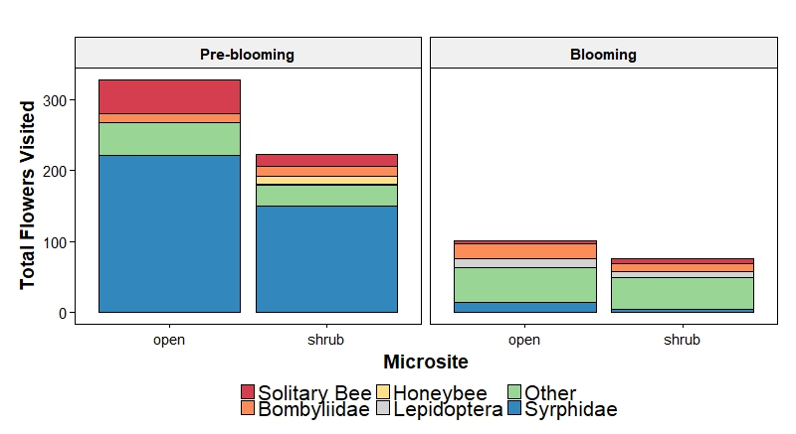

Figure 1: The contribution of each recognizable taxonomic group (RTU) to the total number of flowers visited (weighted by video length) for each treatment.

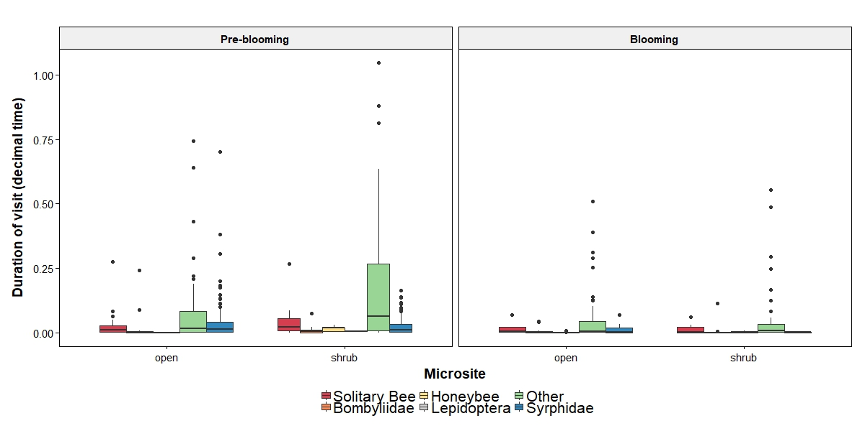

Figure 2: RTU specific responses in visit duration before and during blooming at each microsite.

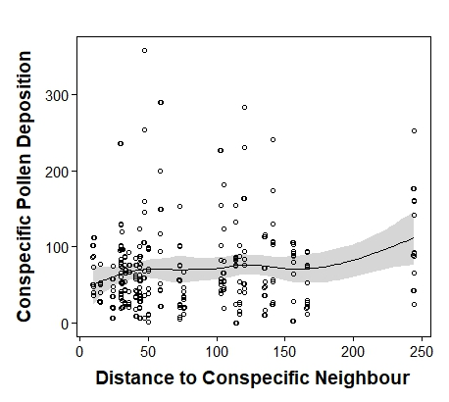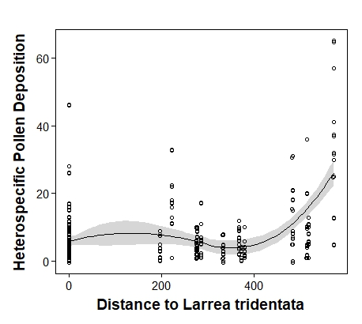

Figure 3: Heterospecific pollen deposition on the stigmas of Malacothrix glabrata increased with distance (in cm). There was a marginally significant effect of distance to nearest M. glabrata on conspecific pollen deposition. Mean distance to shrub was 1.83 m, mean distance to nearest conspecific neighbour was 0.79 m and mean number of flowers of M. glabrata was 7.

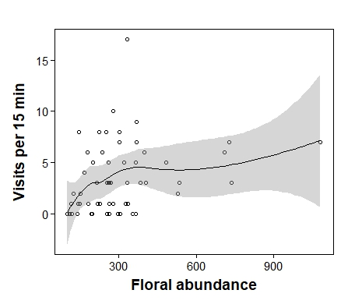

Figure 4: Pollinator visitation rates increased with the number of Larrea tridentata flowers.

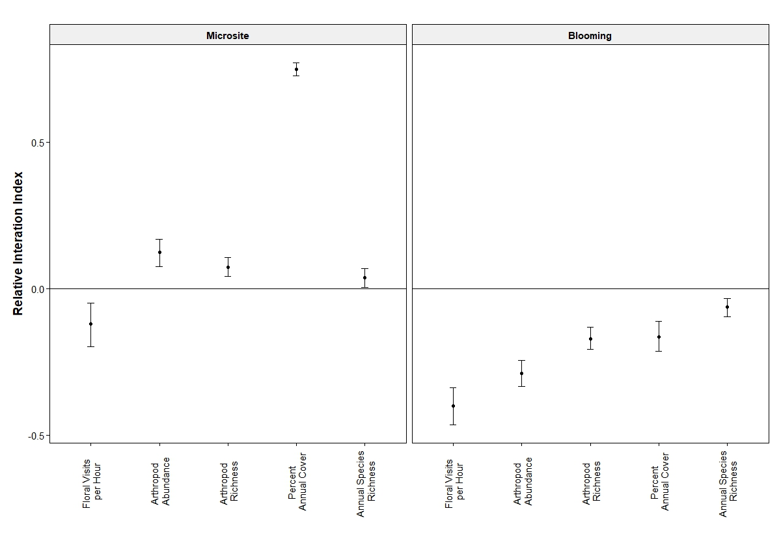

Figure 5: Relative Interaction Index (RII) values for five community interaction metrics among two treatments: Microsite and Blooming. Values shown are means ± 95% bootstrapped confidence intervals. Values greater than zero indicate positive effects, while values that are significantly lower than zero indicate negative effects. Values that are not significantly different from zero are neutral.

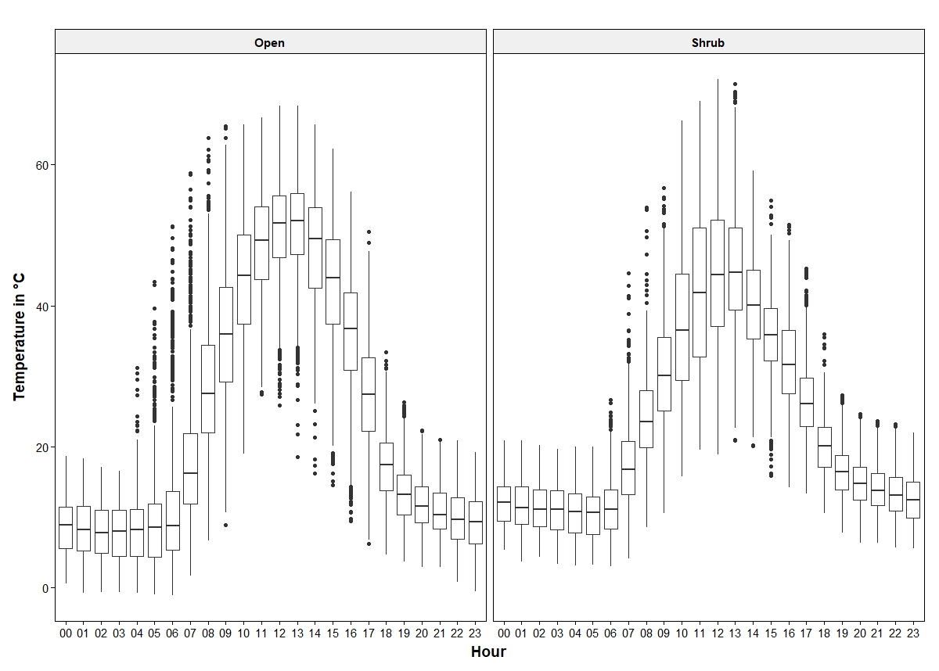

Figure 6: Hobo Pendant Data Loggers recorded microenvironmental conditions for the extent of the study period. Values shown are mean hourly temperatures for all microsites (eight open and eight shrub) between March 17th and May 14th.